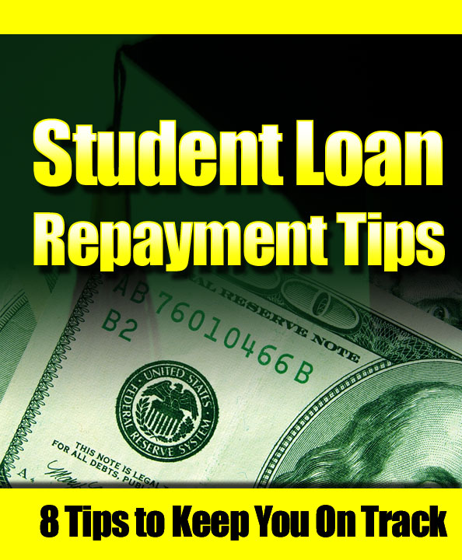
Student Loan Repayment Tips for the Life of Your Loans

It is often said that the most effective debt management strategy is to be debt-free. But, in order to pay for your college education, you may need to take out student loans.

Student loans are applied by many people these days. It is for the hope that student loans can greatly support their education. Well, that is primarily the purpose of student loans, but there are some instances that getting student loans is what lead people to be buried deep in debt. This is common among those who failed to repay their debts or those who actually escape from their obligations.

Now, planning for successful repayment involves a lot of considerations. The planning should start before you place and strike your pen on your first promissory note. Just as you are making a commitment to your career by way of investing time and money in higher education, you should also make a commitment to your financial future by way of effectively managing your student loans from the beginning.

Here are the most recommended tips and tactics that may help you handle your student loan debt effectively and repay the loans successfully.

Tip #1: Do Your Own Research

Always note that not all loans are the same. Some of them, such as the ones provided by the Indiana Secondary Market for instance, offer benefits during school as well as after graduation in the form of repayment incentives, while other do not. They will pay the 3 percent origination fee normally charged on Federal Family Education Loan Program (FFELP) loans, and this process actually means more money for the books, school supplies and living expenses. And, after you graduated, there is a chance that you will be qualified for reduced interest rates especially when you ready your payments up on automatic withdraw. So, with the differences in student loans, it is necessary that you do your research before signing the first promissory note.

Tip #2: Pay Attention to the Mail

Typically, every borrower receives important information regarding the student loan he or she took out. The mail usually comes in before, during and after school. So, it is somehow important that you read all of the materials you receive carefully. In case, you have questions, the source of the materials is available to welcome you with your questions. Don’t hesitate to ask, and never ignore the correspondence or you may miss out a very vital deadlines or details about your loans.

Tip #3: Be Organized

When taking out student loan from a particular institution, it is always best to save all of your student loan documents and correspondences. This makes you aware of what exactly you’ve agreed, what is expected from you as a student loan borrower, and how much you have borrowed. At the start of the student loan process, you may find it unnecessary to keep all the documents, but when the repayment period is approaching, there is a great possibility that you may refer to some or all of these documents.

To makes things easier for you, begin by setting up an easy to use record-keeping system where you can store your student loan documents and correspondence. As you may know, there are a number of books and software products on personal finance to help you get started. Whatever you may use, whether file folders, binders, portfolios, or envelopes, it is a good idea that you set up one folder for every type of loan or account you have and keep the items sorted accordingly.

Here is what you should keep:

- Important documents like your student loan applications, promissory notes, disbursement and disclosure statements, as well as loan transfer notices.
- Copies of all correspondences between you and your student loan lender, loan holder, and/or servicer, including your school’s financial aid office.
- Addresses and telephone numbers of your lender, loan holder, and servicer. These must be maintained up-to-date.
- The name, the date and time of the conversation, as well as a summary of what you have discussed. These must be considered especially when you are speaking with anyone regarding your student loans as these may be valuable for future reference or clarification.

Also, when setting up your record-keeping system, be sure that it is comfortable to use. This means a system that you will find easy to maintain over the life of the loan. This record-keeping system must also be secured from theft or fire. Many experts also suggest that you should keep all your student loan related documents and correspondences until all the education loans you’ve taken have been fully repaid.

Tip #4: Be present at All Required Entrance and Exit Sessions

When you take out student loan, you will be required to complete student loan counseling sessions. This is often considered when you first obtain the loan and upon graduation. Also, it is worth noting that some schools these days offer this on-line and the sessions will not require a great amount of your time. However, they will provide you with a great deal of information on your right and responsibilities as a borrower.

Tip #5: Learn to Manage Money like an Expert

It has been said that if you live like a professional while you are in school, you will live like a student once you’ve finished your degree. In other words, it is important that you know very well how to handle your money while you are attending school. This will help you lessen the total amount you end up borrowing, and in turn, the amount you will responsible for repaying.
Here are some of the tactics that are worth considering:

- Develop realistic budgets for while you are attending school and even after you graduate. This will allow you to borrow not more than you need, giving you a great chance to repay your loans.
- Learn to live as cheaply as you can. Always remember that you are just a student. You will enjoy a more comfortable lifestyle once you’ve graduated especially if you lessen your borrowing while you are in school. Some of the most recommended ideas for how to be thrifty include getting a roommate, renting a movie instead of going out to the theater, as well as bringing your lunch from home instead of eating out. Be thrifty as possible.
- For any credit card bills you receive, try to pay the full amount due.
- Establish a budget for yourself and follow it. While you are in school, it is important that you know how to resist the urge of using credit cards or your student loan funds to purchase things that are included in your budget. Don’t just buy unnecessary things.
- If possible, explore work-study or other part-time employment. As often said, it may give you an opportunity for you to study or obtain valuable professional experience, other than help cover overheads.

Tip #6: Maintain at least Half-Time Enrollment

Considering a half-time enrollment is highly necessary in order for you to qualify for an in-school deferment. The half-time enrollment normally takes six credit hours. Regarding your school’s requirements for half-time status, see your financial aid officer.

Tip #7: Take Advantage of Tax Savings

Some of the student who takes out student loans qualifies for tax credits. To see your own status, check with your tax advisor. The credits are actually based on your qualified tuition payments, and they can help reduce the amount of Federal tax you pay. Now, if you are paying interest on a student loam, you may also be able to take a deduction on your Federal tax return for those interest payments. Therefore, to obtain the full benefit of the credits as well as the deductions, grab the opportunity of employing the additional tax refund to pay down your student loan debt, or perhaps to handle your educational overheads.

Tip #8: Repayment Tips
As you enter the repayment period, note that being aware of your student loan obligations is very crucial. This is where the student loan default usually happens. It occurs when you fail to pay back the loan as agreed or meet the other terms of your promissory note. The promissory note for each of the loans must then be referred prior to your graduation or before you leave school so that you know what your rights and responsibilities are in repayment.

Here is what you should do as you enter the repayment period:
- Send your education loan payments when due every month, for the full monthly payment amount or more. This must be done regardless of whether or not you receive a bill.
- Note and understand the repayment options provided by your student loan lenders. With some available options, there is a possibility that you can lessen the total cost of the loan by making a high monthly payment. Other options may even lessen your initial monthly payments and may make it easier for you to pay back your leans early in your career.
- Understand the deferment as well as forbearance. In case you need them, just learn to exercise your options.
- Remember that the loan consolidation and its repayment options have its pros and cons. So, understand them.
- Keep your school, lender or servicer informed of your whereabouts. Contact them immediately if you change your name or address; have questions about billing statements; have problems making your scheduled payment on time; or if you want information on or application for deferment or forbearance.
- Read, note and understand all the correspondence you receive from your student loan lender, loan holder, or servicer. And, respond them promptly if asked to do so.
For Further Information
If for instance you need further information regarding your student loans, always remember that the financial aid staff at your school is probably your most important resource. However, there are also some consult publications from federal and state governments, lenders and scholarship granting organizations, and financial ad guidebooks that are available from your local bookstore. They are great enough for you to start your own search.

